**References for Assignment**

User => Website Admin (insert, update, delete)

Member => club member (registration)

**Create Database**

**Create table: member**

Id => primary key , **auto_increment**

Create table : member

Id => int , primary key => Save

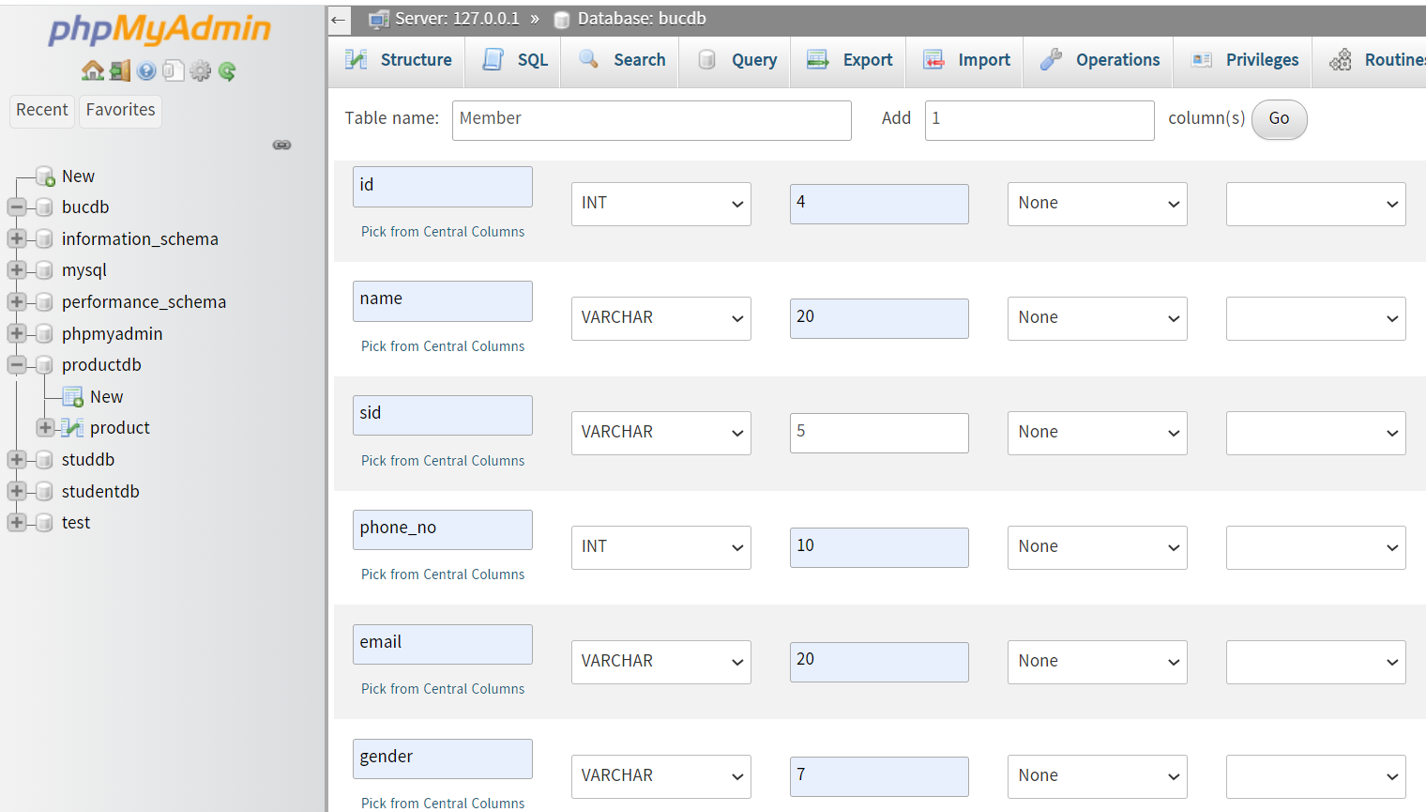

In Structure Tab, id => click change(pencil) => check A_I and Save

In Operation Tab, table_option , set AUTO_INCREMENT

**Insert Data**

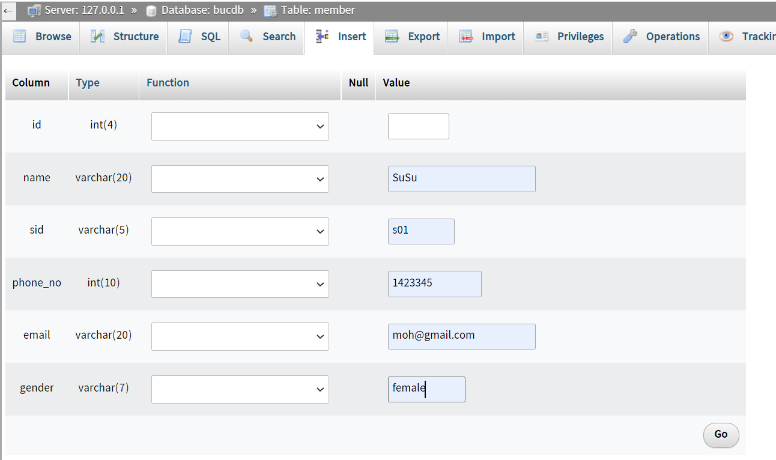

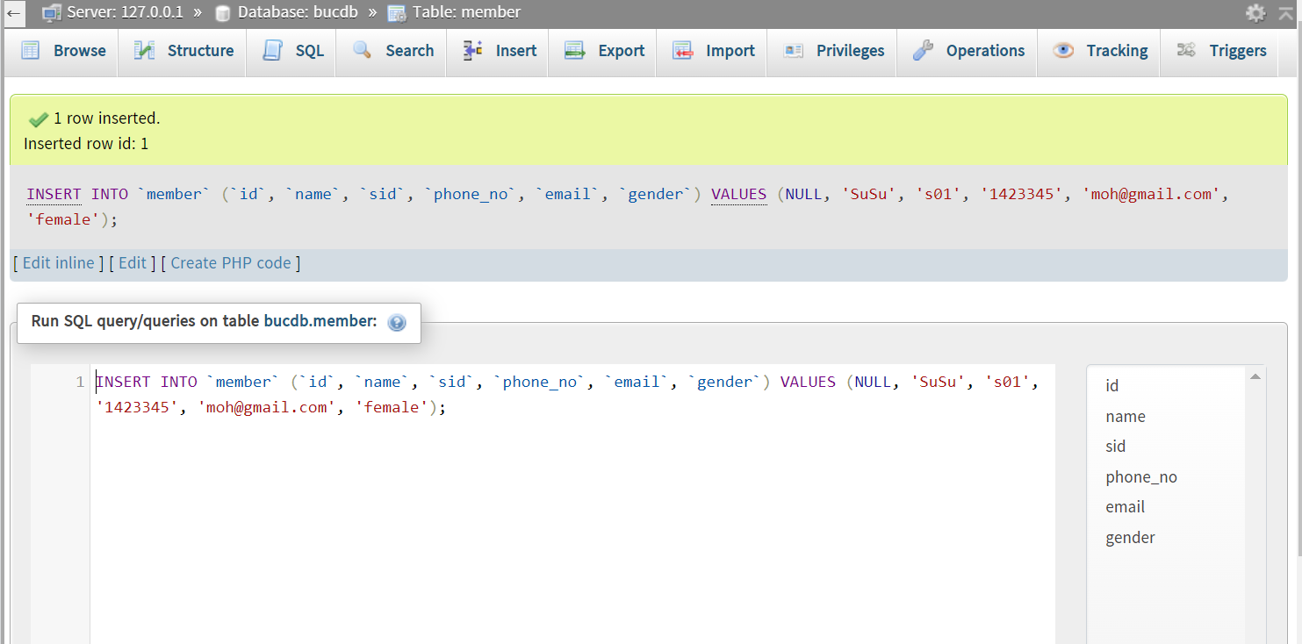

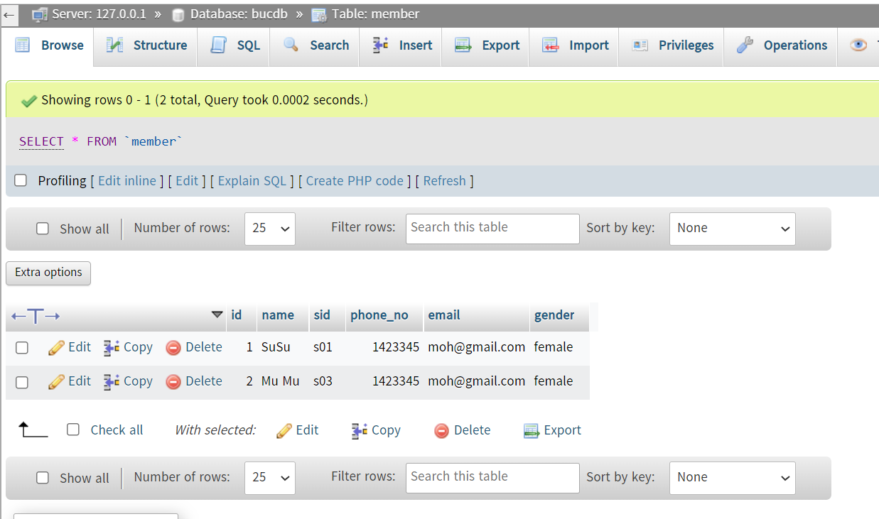

**Create Table :User**

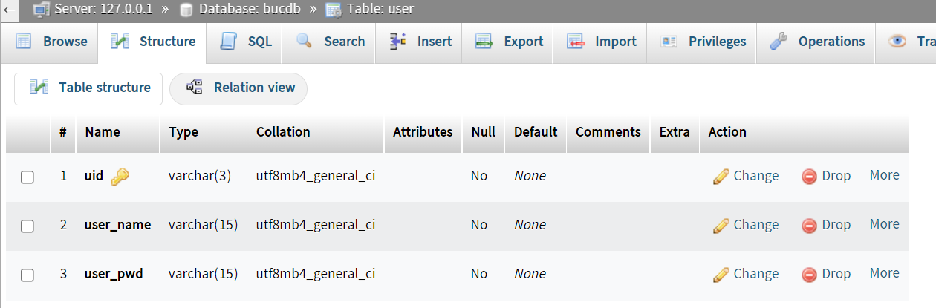

**Table Drop**

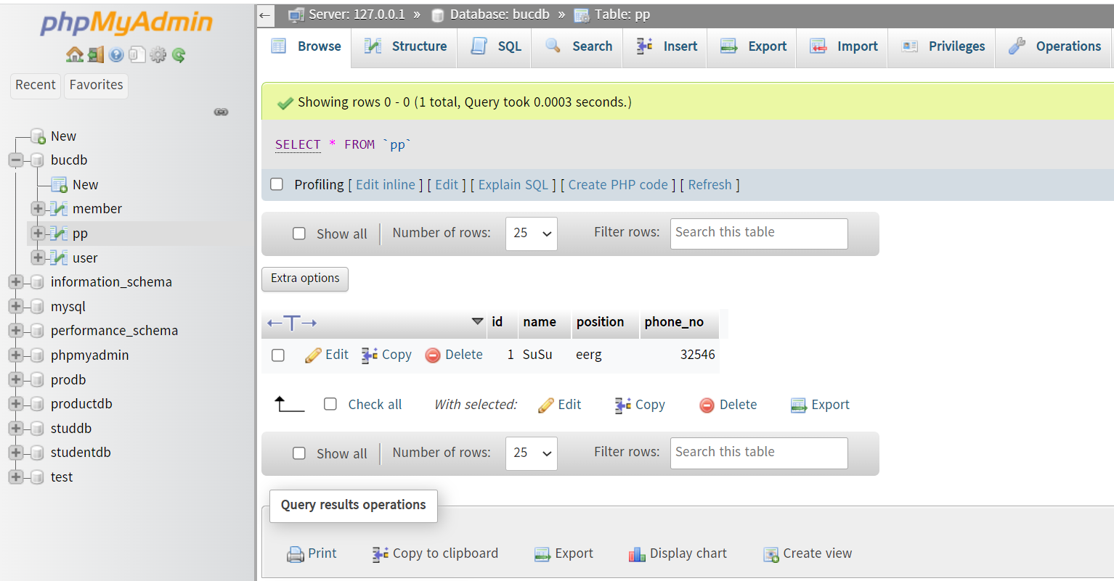

Select Table to drop

Click Operation Tab , click Delete the Table(Drop)

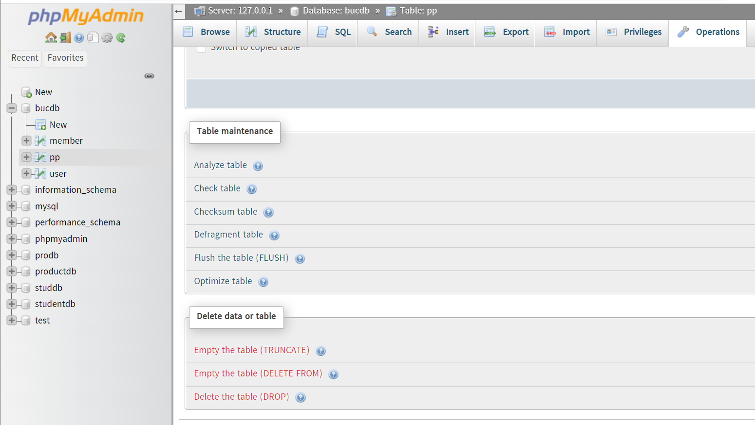

**Drop Database**

Select Database to drop

Click Operation Tab , click Delete the Table(Drop)

**Export Database**

* Log in to the included phpMyAdmin application.
* Select the application database in the left navigation menu.
* Select the “Export” menu item.
* On the resulting page, select the “Quick” export method and the “SQL” output format.
* Click “Go”.

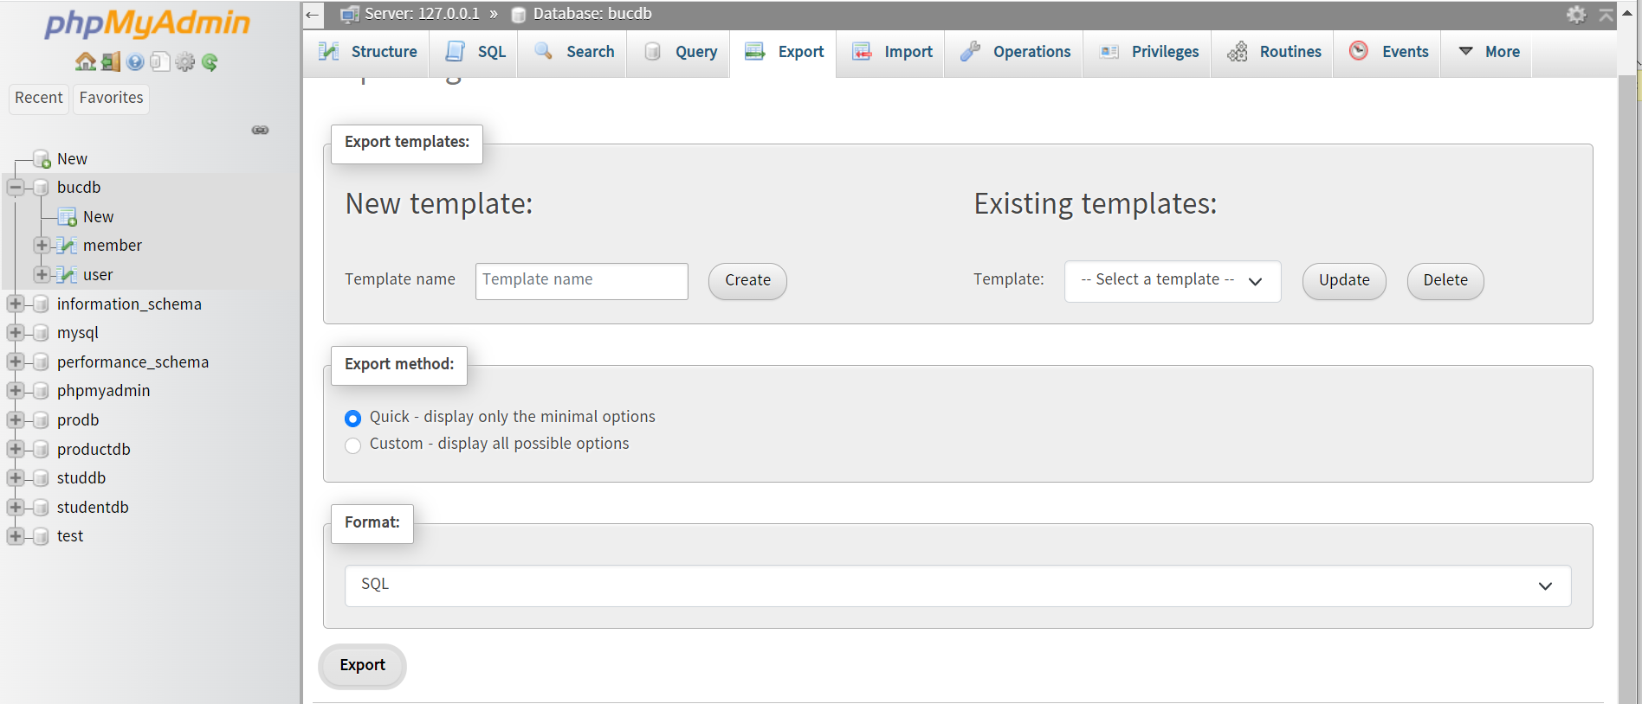

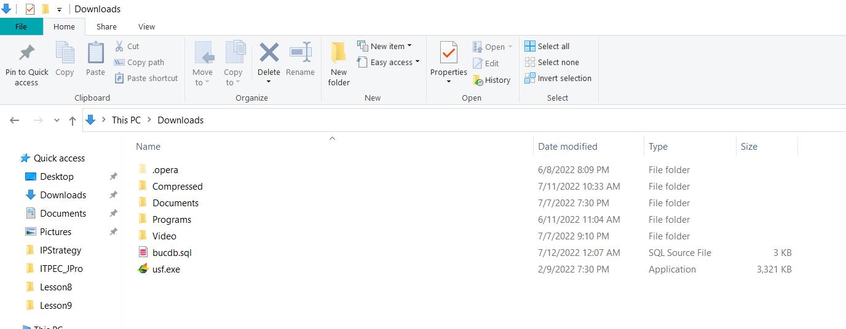

**Import Database**

1. Step 1 - Open your database in phpMyAdmin. ...
2. Step 2 - Click Databases in the top-menu.
3. Step 3 - Click the name of the database you want to import to.
4. Step 4 - Click Import.
5. Step 5 - Choose file and click Go. ...
6. Step 6 - You're done.

Change DB Name(optional)

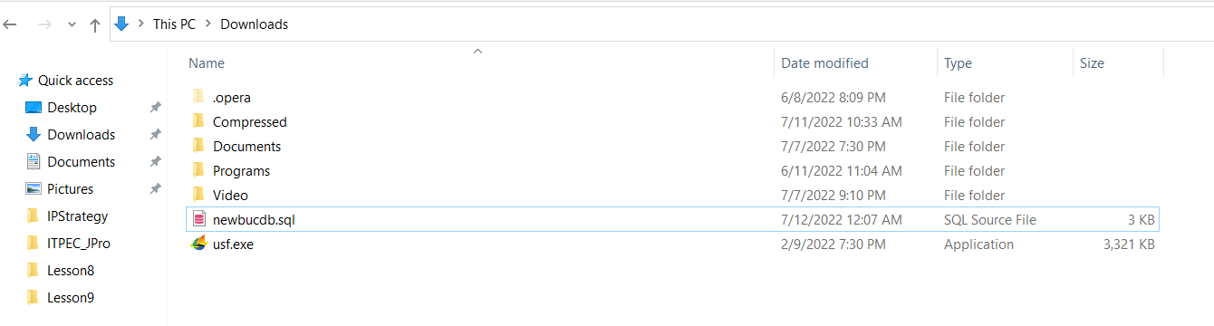

Create Empty Database : importdb

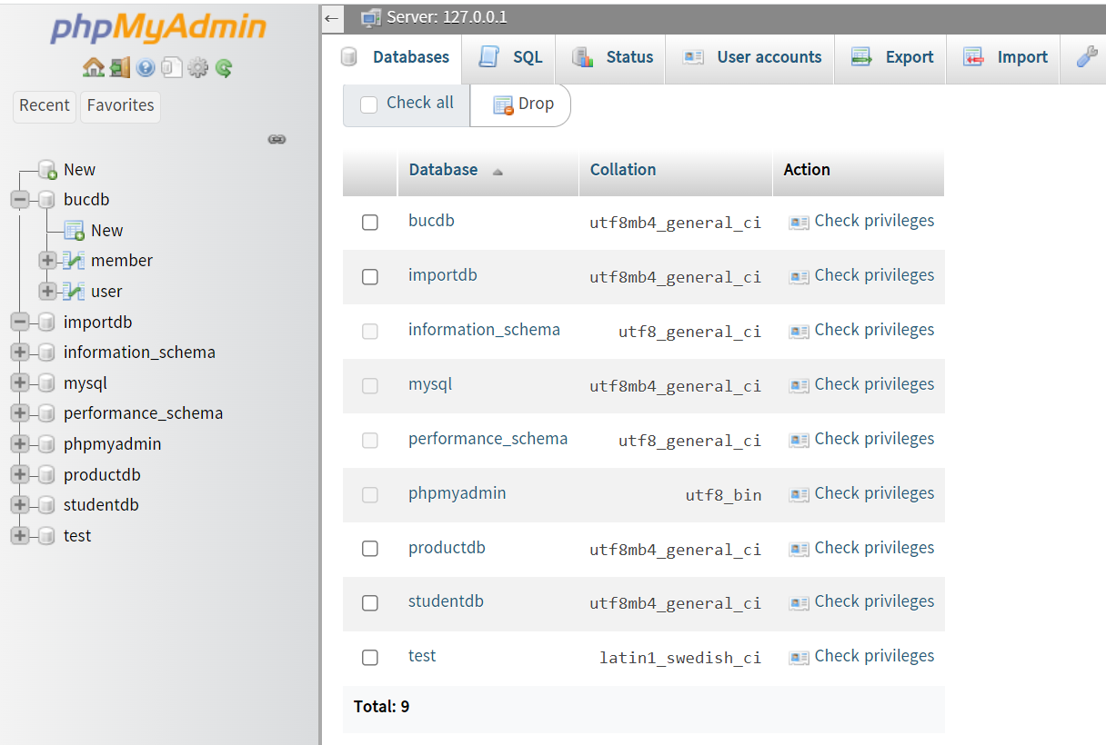

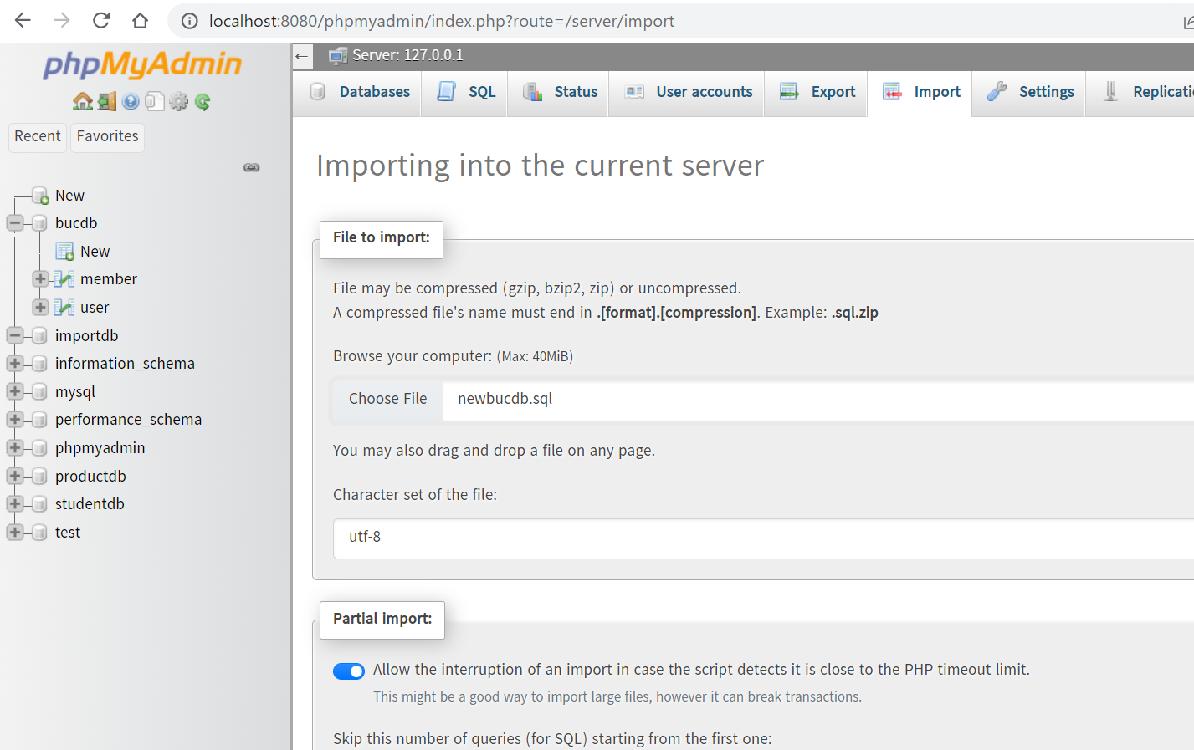

References

<https://www.w3schools.blog/php-program-to-create-login-and-logout-using-sessions>

[**https://blog.hubspot.com/website/php-redirect#:~:text=To%20redirect%20in%20PHP%2C%20you,function%2C%20starting%20with%20header().&text=header('Location%3A%20http%3A%2F%2F,.example.com%2F')%3B**](https://blog.hubspot.com/website/php-redirect#:~:text=To%20redirect%20in%20PHP%2C%20you,function%2C%20starting%20with%20header().&text=header('Location%3A%20http%3A%2F%2F,.example.com%2F')%3B)